General Biology Year 11 2023

Unit 1 – Classification and cell processes

Task 2: Test - Classification

(weighting 10%)

|  |  |  |  |
| --- | --- | --- | --- |
| **Name:** | **Teacher: Mr Opacak** | **Date:** | **Score:**  / |

**Time permitted: 60 minutes**

|  |  |  |  |  |
| --- | --- | --- | --- | --- |
|  | Section | Number of questions | Marks available | Marks achieved |
| A | Multiple choice | 10 | 10 |  |
| B | Short answer | 14 | 32 |  |
| C | Extended answer | 1 | 5 |  |
|  | **Total** | **25** | **47** |  |

**Comments:**

____________________________________________________________________________________________________________________________________________________________________________________________________________________________________________________________________________________________________

**Section A: Multiple Choice (10 marks)**

Section A consists of 10 questions, each worth one mark. Circle the correct answer. Attempt all questions. You are advised to spend no more than 15 minutes on this section.

1. A key in which there are two choices at every branch is commonly known as:
2. Bifurcating key
3. Duolous key
4. Twin key
5. Dichotomous key
6. The lowest two levels in the system of classification are:
7. Class and species
8. Kingdom and order
9. Order and genus
10. Genus and species
11. Humans belong to the genus:
12. *Homo*
13. Mammalia
14. Vertebrata
15. *Hominidae*
16. Using the key below, the figure shown could be identified as:

1. Shape A
2. Shape B
3. Shape C
4. Shape D
5. Term given to describe the 2 name naming system is:
6. Dichotomous key
7. 2 scientific names
8. Binomial nomenclature
9. Binomial key
10. The following are used to provide reference collections for classification of unknown species:
11. Museums and herbariums
12. Museums
13. Zoos
14. Museums, herbariums and zoos
15. How Australian Aboriginal people classify organisms?
16. They only give a specific name to those that have a special use to them
17. They only give a specific name to those that have a special significance or use to them
18. They use the 2 name naming system
19. They divide organisms into land, water and air dwellers
20. Organisms which are members of the same order must also be members of the same…
21. genus
22. species
23. class
24. family
25. Members of the same species…
26. May belong to different genera
27. Are able to mate and produce fertile offspring
28. Usually have different scientific binomial name
29. Are all identical to one another
30. The scientific (and common) names of three animals are: *Canis familiaris* (dog), *Canis lupis* (wolf) and *Vupes vulpes* (fox). These three animals all belong to the same:
31. Species but different genera
32. Genus but different species
33. Class but different species
34. Genus but different classes

**Section B: Short Answer (32 marks)**

Section B consists of 15 questions. Write your answers in the spaces provided. You are advised to spend 35 minutes on this section.

1. Define the following terms: (2 marks)

Classification

______________________________________________________________________________________________________________________________________________________________

Biodiversity

______________________________________________________________________________________________________________________________________________________________

1. List two reasons why biologists classify living things. (2 marks)
2. __________________________________________________________________________________________________________________________________________________
3. __________________________________________________________________________________________________________________________________________________
4. Complete the following: (2 marks)

Organisms are divided. First into:

K _____________________________________

These are then subdivided into:

P _____________________________________

Then

C______________________________________

O _____________________________________

F _____________________________________

G _____________________________________

S _____________________________________

1. List two criteria scientists use to separate organisms into groups. (2 marks)
2. __________________________________________________________________________________________________________________________________________________
3. __________________________________________________________________________________________________________________________________________________
4. Why are two words used in the scientific naming system? (2 marks)

_____________________________________________________________________________________________________________________________________________________________________________________________________________________________________________

1. What rules are followed in writing the scientific name? (2 marks)

_____________________________________________________________________________________________________________________________________________________________________________________________________________________________________________

1. Which two organisms listed below are likely to be most similar?
2. *Helichysum pungens*
3. *Hibbertia longiflora*
4. *Acacia longiflora*
5. *Hibbertia scandens*

____________________________________________________________________________

(1 mark)

Explain your choice. (2 marks)

____________________________________________________________________________________________________________________________________________________________________________________________________________________________________

1. How would a biologist determine whether two mammals belonged to the same species or not?

(2 marks)

_____________________________________________________________________________________________________________________________________________________________________________________________________________________________________________

1. The following lists show the scientific name and the common name of some native Australian plants.

|  |  |
| --- | --- |
| Scientific name | Common name |
| *Leucopogon attenuatus* | Old Man’s Beard |
| *Dichondra repens* | Kidney weed |
| *Phyta nodiflora* | Fog-fruit |

Explain why a scientist would use the names in left column, whereas a nurseryman in Western Australia is more likely to use the common names in the right column. (2 marks)

____________________________________________________________________________________________________________________________________________________________________________________________________________________________________________________________________________________________________________________________

1. Identify the animal in the dichotomous key that has four legs and hooves, but does not have a woolly coat or four toes on each foot. (1 mark)

Name of organism: __________________________________________

1. Use the invertebrate dichotomous key to identify which group the following organisms belong to. (2marks)

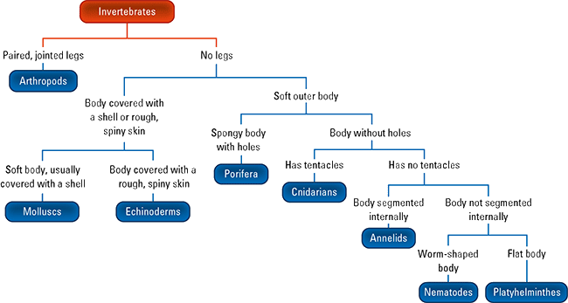

1. Starfish ________________________
2. Butterfly ________________________
3. Based on the information in the classification key shown below, construct Venn diagram to compare the flowering plants and conifers. (3 marks)

**FLOWERING PLANTS**

**CONIFERS**

1. Use the key below to classify the animals pictured below. (3 marks)

1. ____________________________________________
2. ____________________________________________
3. ____________________________________________
4. Complete the following table which shows the characteristics of some types of animals. (2 marks)

|  |  |  |
| --- | --- | --- |
| **Classification** | **Characteristics** | **Examples** |
| Arthropods |  |  |
| Molluscs | Soft-bodied animals, large muscular foot, usually have a shell | Snails, slugs, squid |

1. **Outline** the impact of technological advances on the development and revision of biological classification systems. (2 marks)

________________________________________________________________________________________________________________________________________________________________________________________________________________________________________________________________________________________________________________________

**Section C: Short Answer (5 marks)**

Section C consists of 1 question. Write your answers in the spaces provided. You are advised to spend 10 minutes on this section.

1. Construct a branching dichotomous key that could be used to classify the following organisms: snail, worm, insect, spider and human. (5 marks)

